CSC430/530 – Database Management Systems

Lab 0 – Creating & populating the database.

**Part A – Creating DB and tables, defining domains of attributes & entity integrity constraints (primary keys).**

Create database and define schemas for every relation (table).

* First, open phpMyAdmin and click on "SQL".
* To create the database named “company”, put the following in the SQL editor:

CREATE DATABASE company;

* Click the "Go" button to run the query (or press ctrl+enter).
* Click on the created "company" database in the left panel
  + if using command line, this is the same as entering: use company;
* Next, we will create a schema and define domain & entity integrity constraints for every relation:
* To do this, in the SQL editor for the company database, enter the following one at a time:
  + Employee relation:

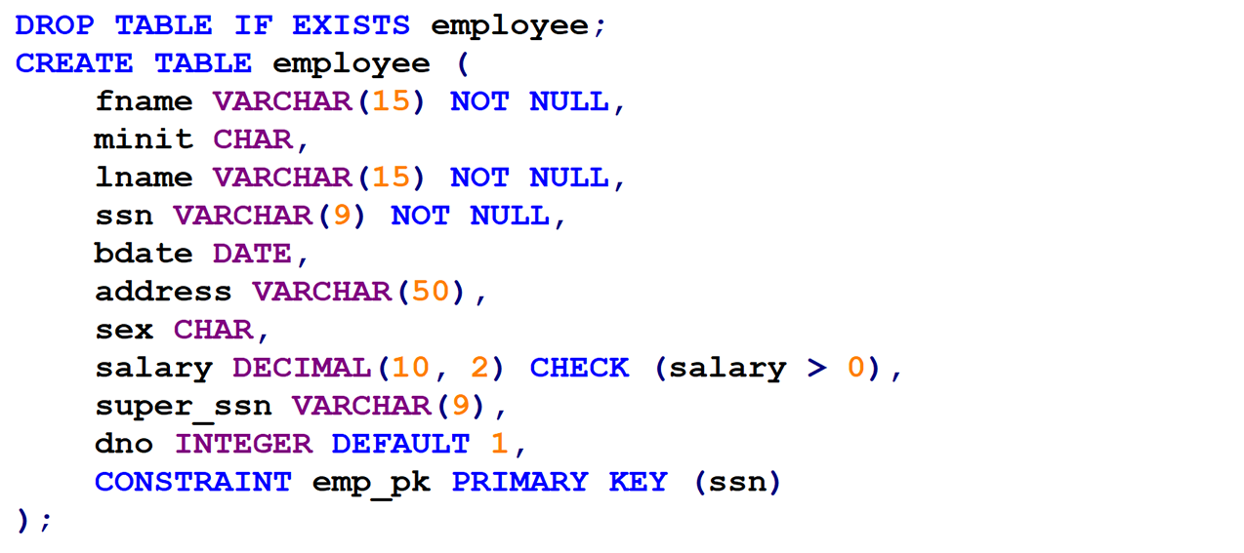

* + Dependent relation:

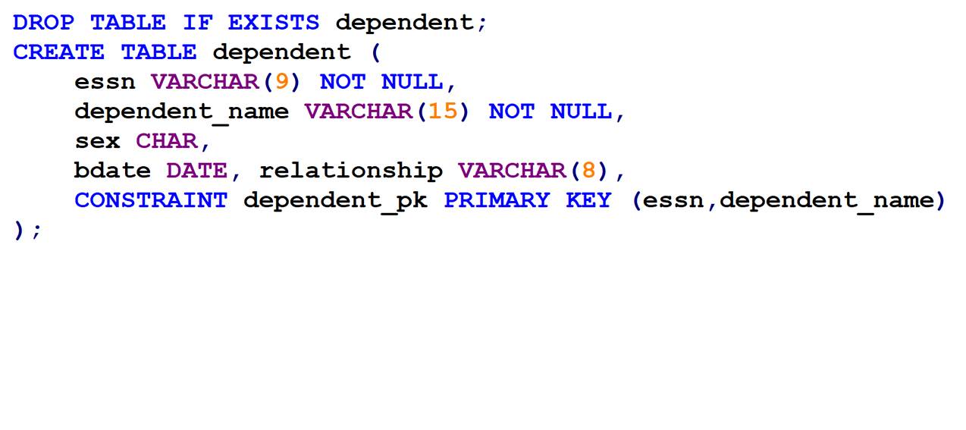

* + Department relation:

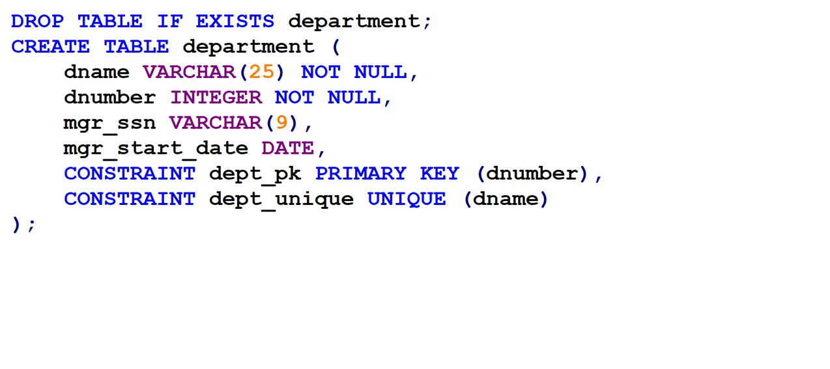

* + Department locations relation:

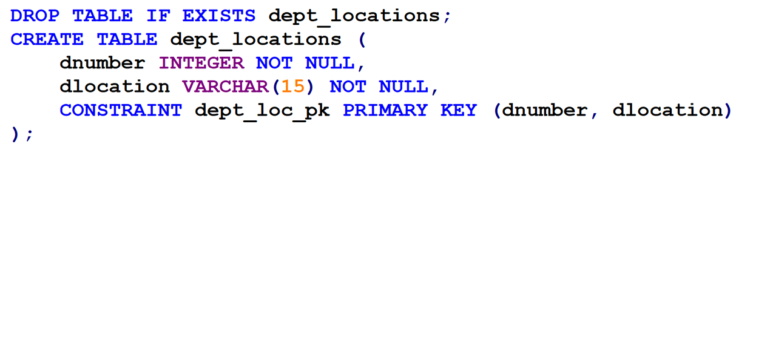

* + Project relation:

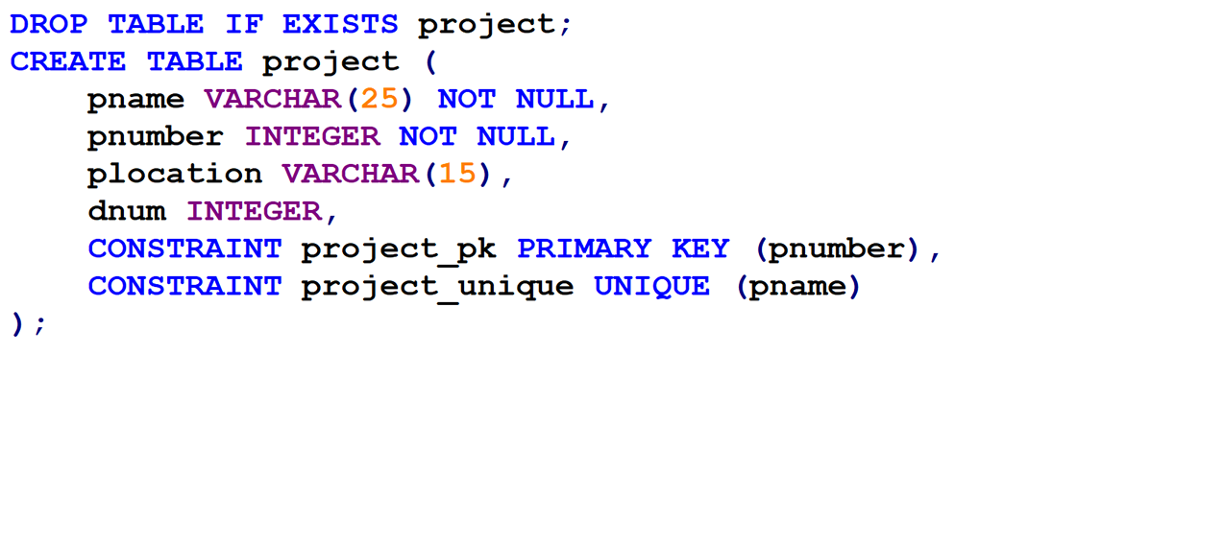

* + Works on relation:

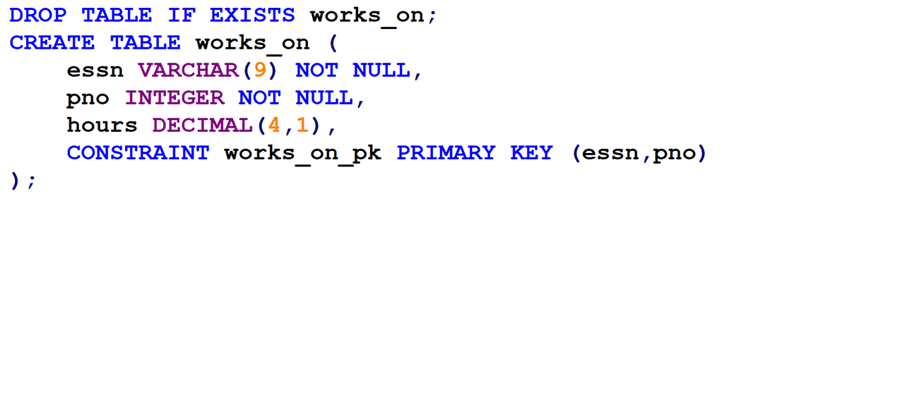

**Part B – Defining referential integrity constraints.**

Once the schemas with domain and entity integrity constraints are defined, we can define referential integrity constraints (foreign keys).

* In SQL query editor:
  + Employee relation:

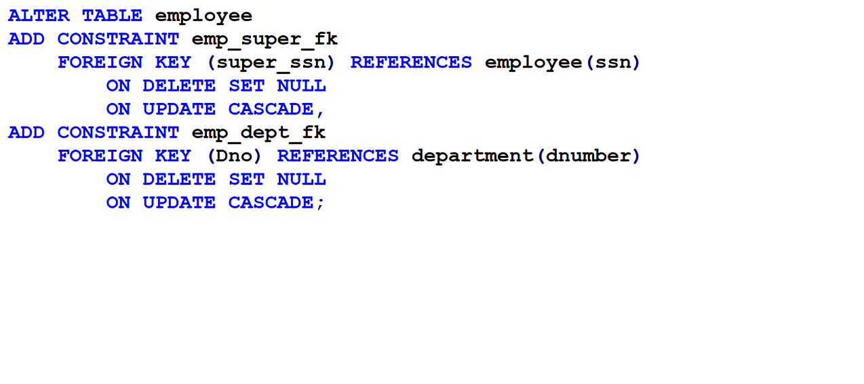

* + Dependent relation:

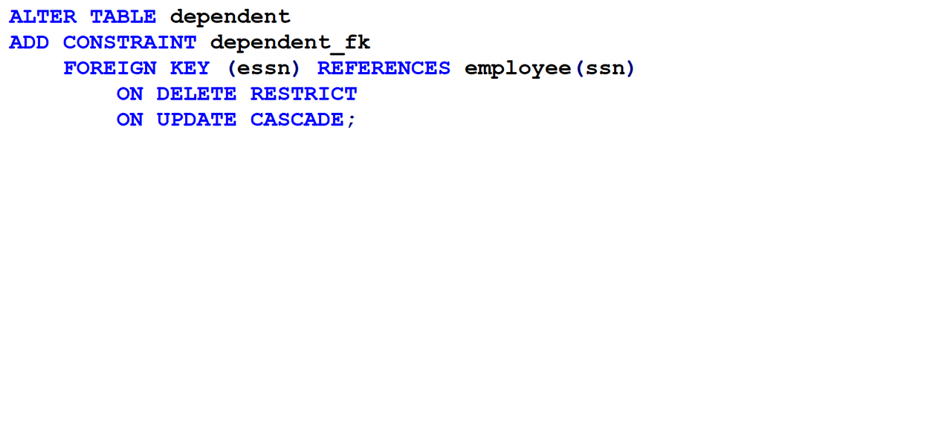

* + Department relation:

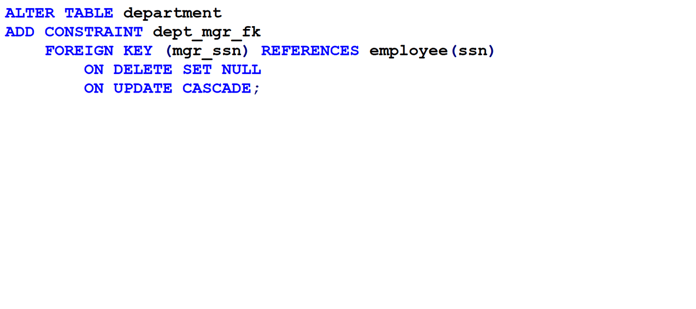

* + Department locations relation:

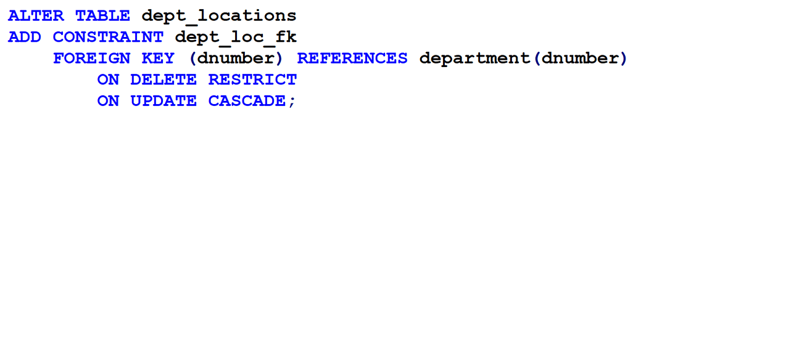

* + Project relation:

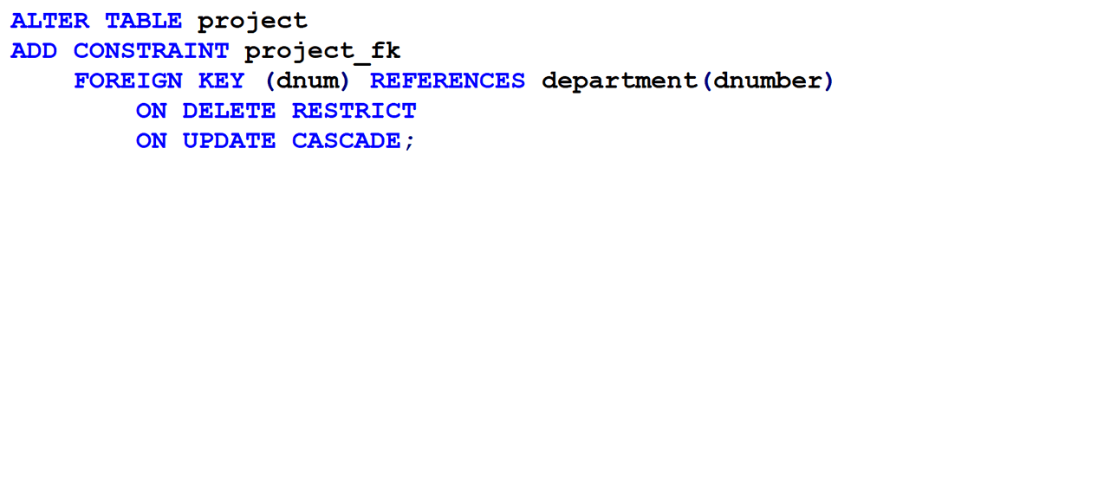

* + Works on relation:

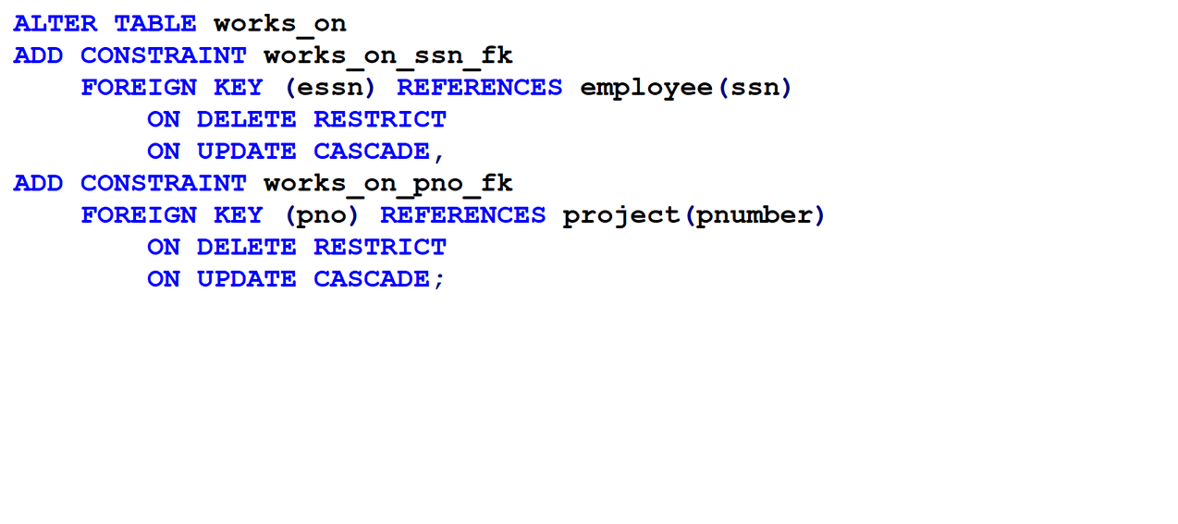

**Part C – Populating the DB.**

Parts A & B conclude the definition of the database schema. Next step is to create database state, i.e. populate the database with data.

Database can be populated in three ways:

* Manually, using INSERT DML command.
* Through “Import” (at the top navigation after selecting a table).
  + Accepts data in multiple formats.
* Dump data through command line (shell), using LOAD DATA INFILE command.
  + Accepts data in any text file format.

We will use the import option. Do the following for each table:

* Click on a table in the database
* Go to the Import page (click on "Import" at the top).
* Under "File to import", click on "Choose File" and find the .dat file for that table. These files can be found on Canvas in a zip file for Lab 0.
* Scroll down to "Other options" and uncheck "Enable foreign key checks".
* Change the "Format" to "CSV".
* Click "Import" button at the bottom.
* Repeat this for all 6 tables.